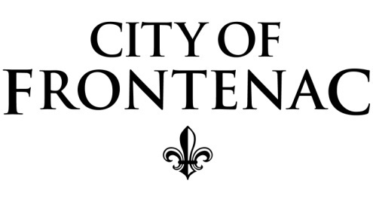

FRONTENAC BOARD OF ALDERMEN

SPECIAL MEETING AGENDA
MONDAY, APRIL 26, 2021, 2020, 4:00 P.M.

In light of the current public health crisis and the Federal, State and County Emergency Declarations, and in accord with the provisions of Sec. 610.020, RSMo., the City recognizes that it would be dangerous and impractical, if not impossible, for meetings to be physically accessible to the public. The City also recognizes the need for the public’s business to be attended to in order to protect the public health, safety and welfare. In order to balance both the need for continuity of government and protection of the health and safety of our residents, business persons and employees, this meeting of the Board of Aldermen will not be open to public attendance in person. The meeting will be accessible by the public in real time ONLY by audio conference call.

Instructions to phone into the meeting:

Board of Aldermen Meeting
United States: +1 (646) 749-3122
Access Code: 972-748-133

CALL TO ORDER

B. PLEDGE OF ALLEGIANCE
C. ROLL CALL

D. VOTE TO APPROVE AGENDA

E. UNFINISHED BUSINESS:
- Bill No. 2021-1988: An ordinance reinstating salary step increases for all employees for fiscal year 2020-2021. (First reading occurred on April 20, 2021)

- Continue discussion to begin the contract with H3 Studio Inc. for the comprehensive plan.
F. NEW BUSINESS: None

G. EXECUTIVE SESSION FOR R.S. MO 610.021 (1) LEGAL
H. VOTE TO ADJOURN

